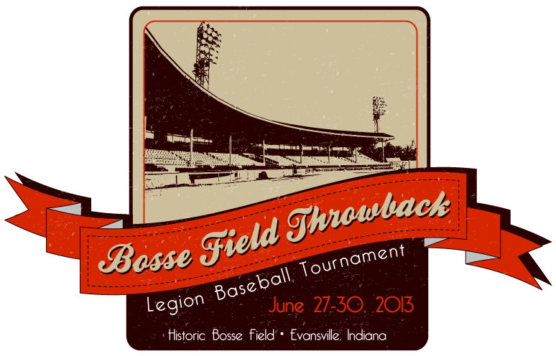

2013 Bosse Throwback Tournament

June 27, 2013 – June 30, 2013

Thank you for choosing to come to the 2013 Bosse Throwback Tourney, hosted by Eugene Pate Post 265! We have talented teams from all over the Mid-West converging on Evansville and should have a great tournament. The rules and tournament schedule were set up to ensure fairness to all teams and to allow for great baseball for our boys. In addition, college coaches from around the area will be in attendance to scout for college prospects.

- Sites: Bosse Field, Central High School, Washington Middle School (Bosse High School’s home field, very nice), Castle High School
- 12 Teams – 5 games each + Championship Round
- 2 Pods – American and National
- All games will be 7 innings
- Coin flip will determine the home team. On Sunday, the higher seed will be home team (same seed in Championship game will result in coin flip)
- A short infield can be taken before your first game of the day, ONLY if time allows…..with teams playing at different locations, we must do our best to stay on schedule.
- We will be hosting a BBQ dinner and Home Run Derby at Bosse Field, Friday 6/28 from 6:00-8:00.
- Play to begin on Thursday 6-27-13 at Central High School, Washington Middle School, Castle High School and will end on Sunday 6-30-13 with the Championship Rounds at Bosse Field.
- Each team will have 5 scheduled games against teams in their respective pods. The 1st and 2nd Place teams from each pod will advance to the Sunday Championship Rounds. Tie Breakers will be as follows to determine pod winner and runner-up:

- Head to Head Record
- Runs Allowed
- Runs Scored
- Home Runs Hit
- Coin Flip

  - If there is a 2-way tie in head to head record, runs allowed will be used to determine which team is the pod winner and which team is the runner up. If runs allowed are tied, then the runs scored will be used and so on.
  - If there is a 3-way tie for best record the same process will be used. Once one tiebreaker is satisfied and moved past for the 3 teams, we will not refer back to the previous tie breaker to determine the team that will advance. For example: Team 1, Team 2, and Team 3 have 3-1 records at end of Pod play with Team 1 beating Team 2, Team 2 beating Team 3, and Team 3 beating Team 1. Tie Breaker 1 determines no winner or runner-up so we move to the next tie breaker. Team 1 allows 10 runs, Team 2 allows 17 runs and Team 3 allows 15 runs. Team 1 will be the Pod winner based on the runs allowed tie breaker. Team 3 will be the runner-up based on the same tie breaker even though they lost to team 2 head to head. We will not revert back to determine who moves on.

Bosse Throwback Tourney-June 27-30, 2013

American Pod
Eugene Pate Post 265 (Evansville IN)
Piatt County Legion (Bement, IL)
Boonville Post 200 (Boonville, IN)
William A. Doyle Post 236 (Calvert City, KY)
Sullivan Post 139 (Sullivan, IN)
Crawfordsville Bryon Cox Post 72 (Crawfordsville, IN)

National Pod
Newburgh Post 44 (Newburgh, IN)
House Springs Post 783 (House Springs, MO)
Blissfield Big League Post 325 (Blissfield, MI)
Floyds Knobs Post 42 (Floyds Knobs, IN)
Princeton Post 25 (Princeton, IN)
Belleville Post 58 (Belleville, IL)

Central High School

Thursday
10:00 Eugene Pate v. Boonville
12:30 Eugene Pate v. Sullivan
3:00 Princeton v. House Springs
5:30 Belleville v. House Springs
8:00 Crawfordsville v Decatur

Friday
10:00 Belleville v Blissfield
12:30 Floyds Knobs v Blissfield
3:00 Sullivan v Boonville
5:30 Eugene Pate v Calvert City
8:00 Eugene Pate v Crawfordsville

Saturday
10:00 Decatur v Calvert City
12:30 Crawfordsville v Sullivan
3:00 Crawfordsville v Boonville
5:30 Eugene Pate v Decatur
8:00 Princeton v Blissfield

Castle High School, Newburgh, IN

Thursday
4:30 Newburgh v Floyds Knobs
7:00 Newburgh v Blissfield

Friday
3:30 Newburgh v House Springs

Saturday
3:30 Newburgh v Princeton
6:00 Newburgh v Belleville

Washington Middle School

Thursday
11:00 Princeton v Floyds Knobs
1:30 Calvert City v Boonville
4:00 Sullivan v Decatur

Friday
10:00 Decatur v Boonville
12:30 Calvert City v Crawfordsville
3:00 Belleville v Princeton

Saturday
9:00 House Springs v Floyds Knobs
11:30 House Springs v Blissfield
2:00 Floyds Knobs v Belleville
4:30 Calvert City v Sullivan

Bosse Field

Sunday
10:00 American Pod #2 v. National Pod #1

12:30 American Pod #1 v. National Pod #2

3:00 Championship Game

